PROCEDURES IN ENTITY FRAMEWORK

User

USING PROCEDURES FOR

CREATE

READ

UPDATE

DELETE

**OPERATIONS(CRUD)**

STORED PROCEDURES IN EF

1. **IT AUTOMATICALLY BUILDS SQL COMMANDS FOR DB USING LINQ**
2. **BUILDS CMDS TO INSERT, UPDATE,DELETE OR TO RETRIEVE/READ RECORDS**
3. **CREATES A FUNCTION IN EDM FOR EACH STORED PROCEDURE AND UDF(USER DEFINED FUNCTION) IN TARGET DB**

**INSERT PROCEDURE**

GO

SET ANSI_NULLS ON

GO

SET QUOTED_IDENTIFIER ON

GO

CREATE PROCEDURE [DBO].[INSERTDEPTLOC]

@areaid int,

@areaname varchar(50),

@cityid int,

@phone bigint

as

insert into DEPTLOC values (@areaid,@areaname,@cityid,@phone)

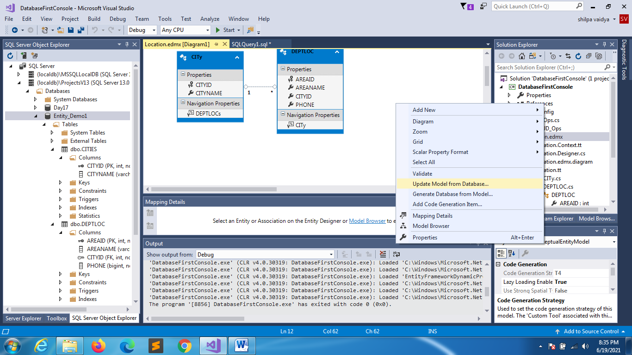

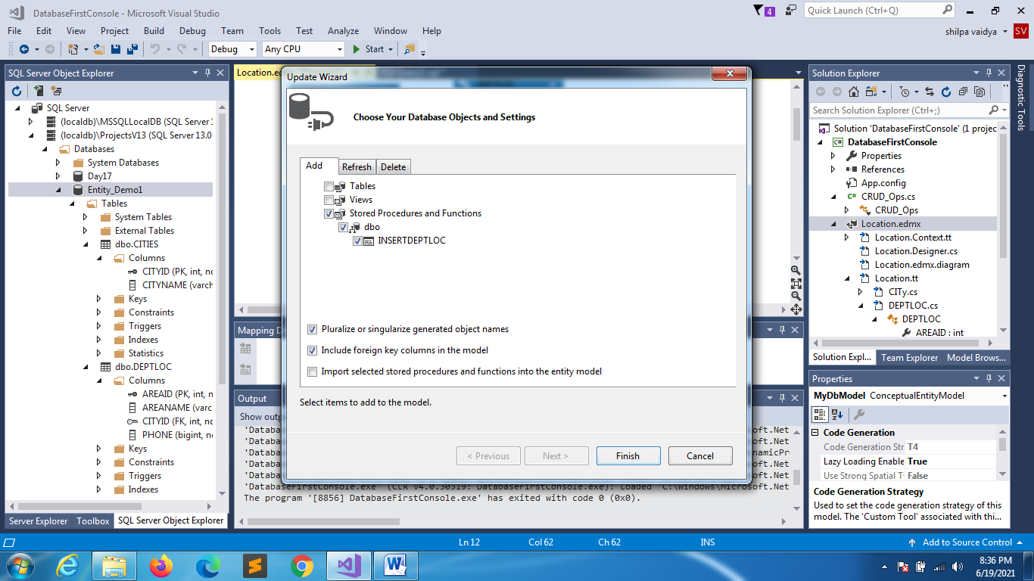

UNCHECK

**WE HAVE TO WRITE ALL OTHER 3 PROCEDURES**

GO

SET ANSI_NULLS ON

GO

SET QUOTED_IDENTIFIER ON

GO

CREATE PROCEDURE [DBO].[UPDATEDEPTLOC]

@areaid int,

@areaname varchar(50),

@cityid int,

@phone bigint

as

UPDATE DEPTLOC SET

AREANAME =@areaname,

CITYID =@cityid,

PHONE =@phone

WHERE AREAID =@areaid

UPATE

PROCEDURE

GO

SET ANSI_NULLS ON

GO

SET QUOTED_IDENTIFIER ON

GO

CREATE PROCEDURE [DBO].[DELETEDEPTLOC]

@areaid int

as

DELETE FROM DEPTLOC

WHERE AREAID =@areaid

DELETE

PROCEDURE

GO

SET ANSI_NULLS ON

GO

SET QUOTED_IDENTIFIER ON

GO

CREATE PROCEDURE [DBO].[SELECTDEPTLOC]

as

SELECT * FROM DEPTLOC

SELECT

PROCEDURE

**REPEAT SAME PROCESS OF UPDATING THE ENTITY MODEL**

**UNCHECK IMPORT AND SELECT PROCEDURE**

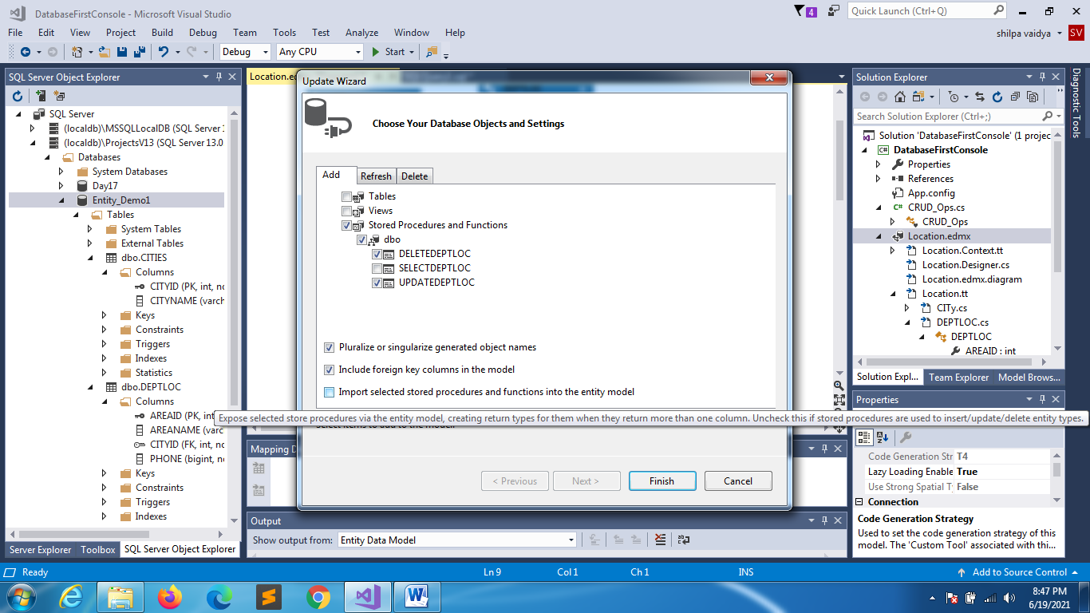

**STORED PROCEDURE MAPING FOR**

**1 UPDATE 2 DELETE 3 INSERT**

**RIGHT CLICK ON DEPTLOC ENTITY:**

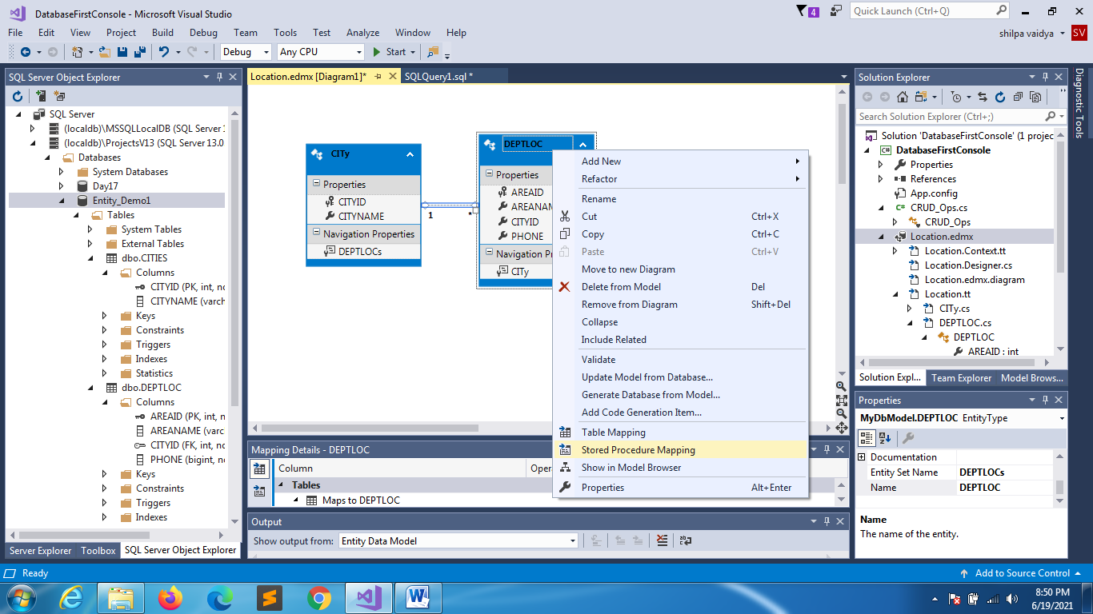

**YOU WILL GET THIS**

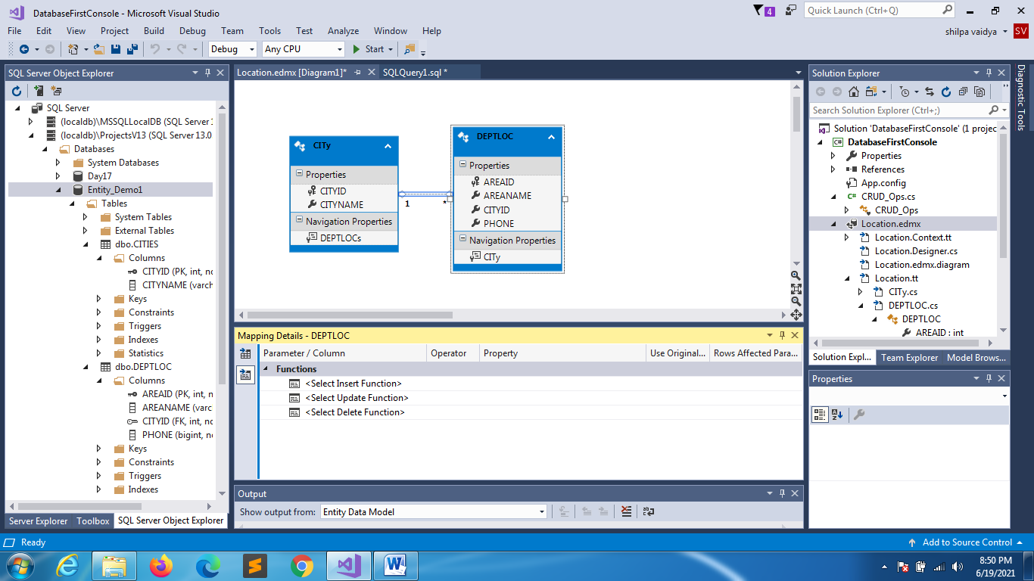

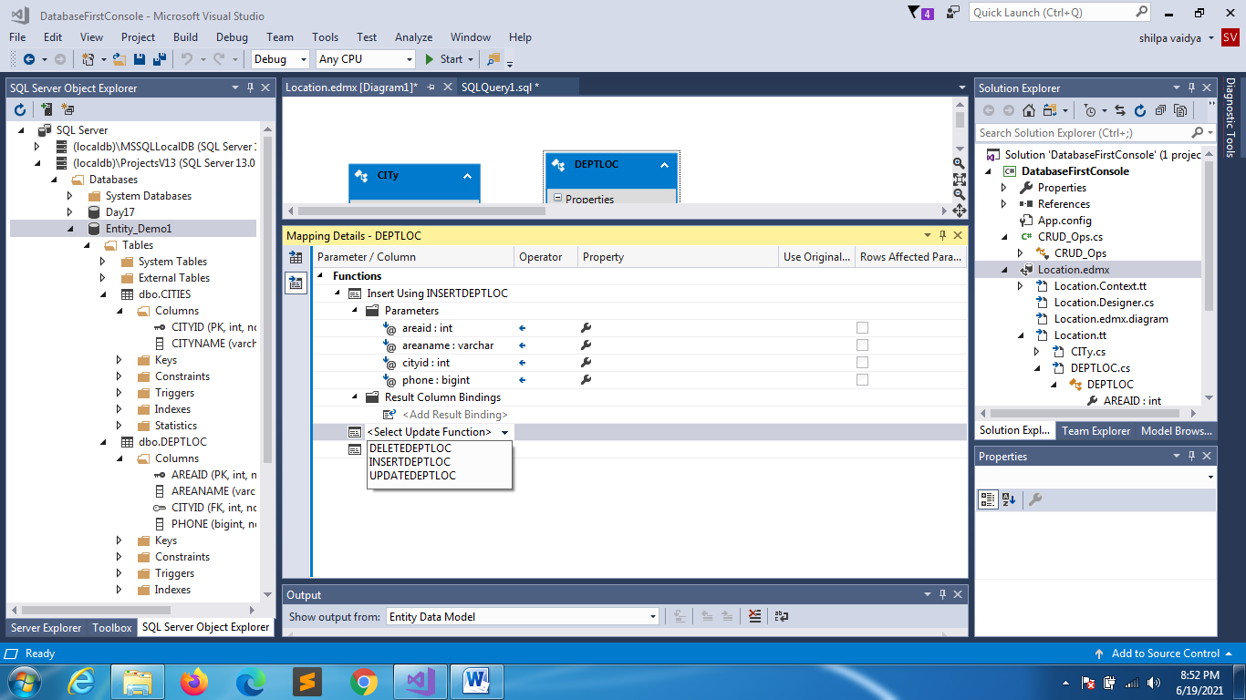

CLICK THE DROPDOWNS ON THE MATCHING TABLE:

MAP MATCHING PROCEDURE

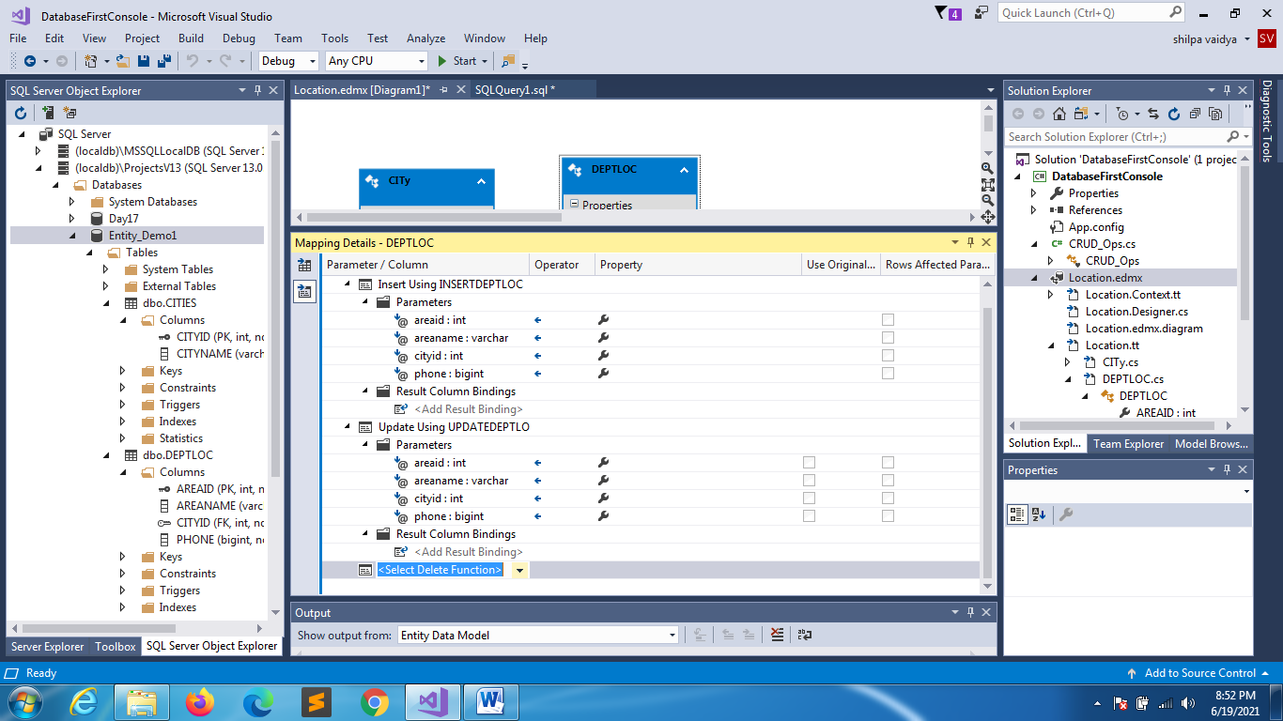

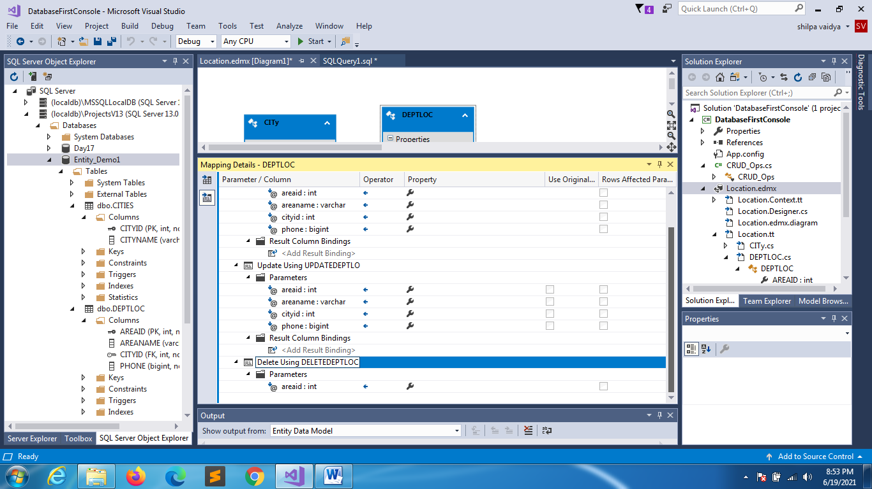

**MAP PROCEDURE PROPERTIES AS WELL**

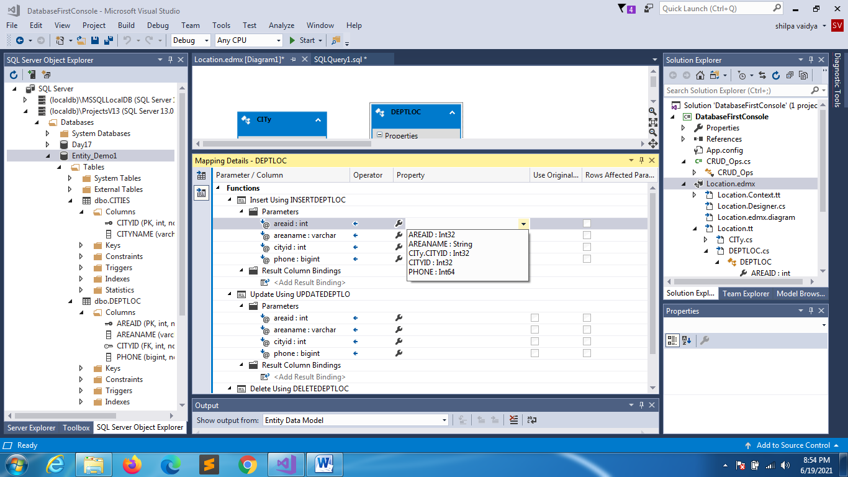

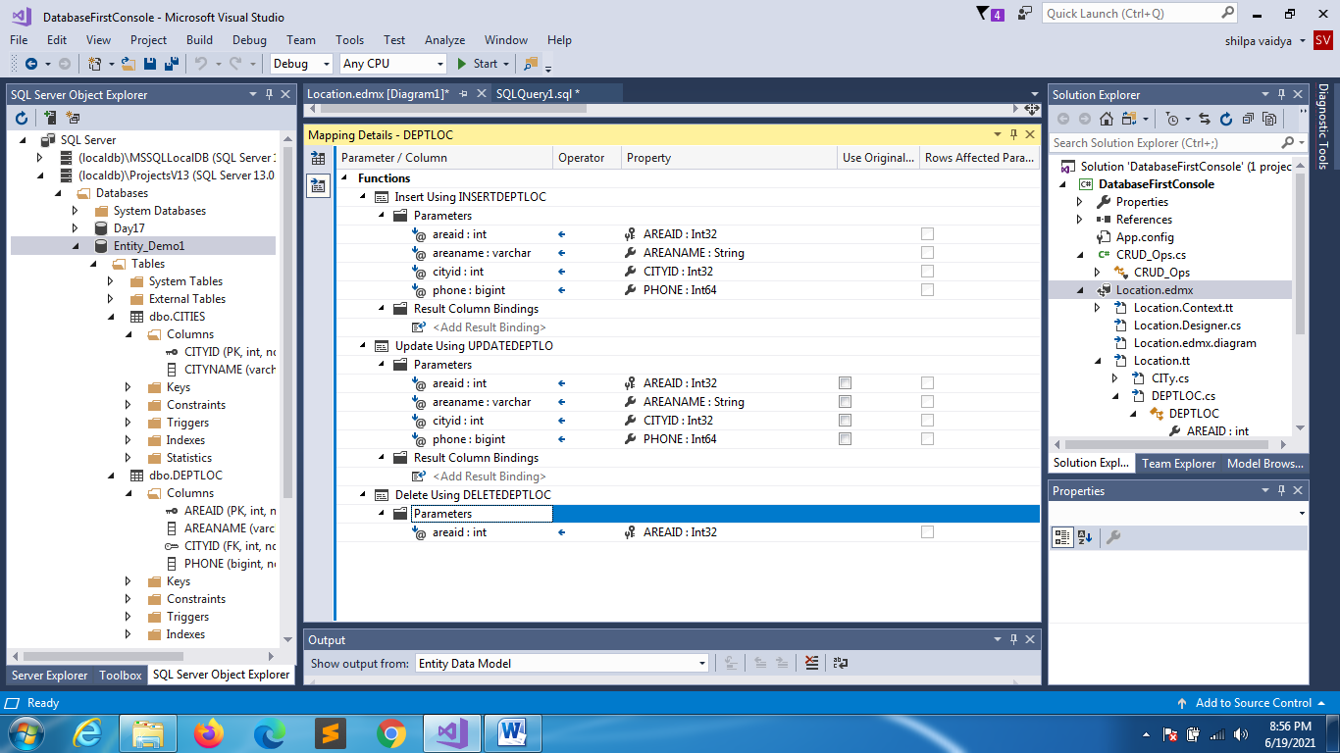

VALIDATE IT

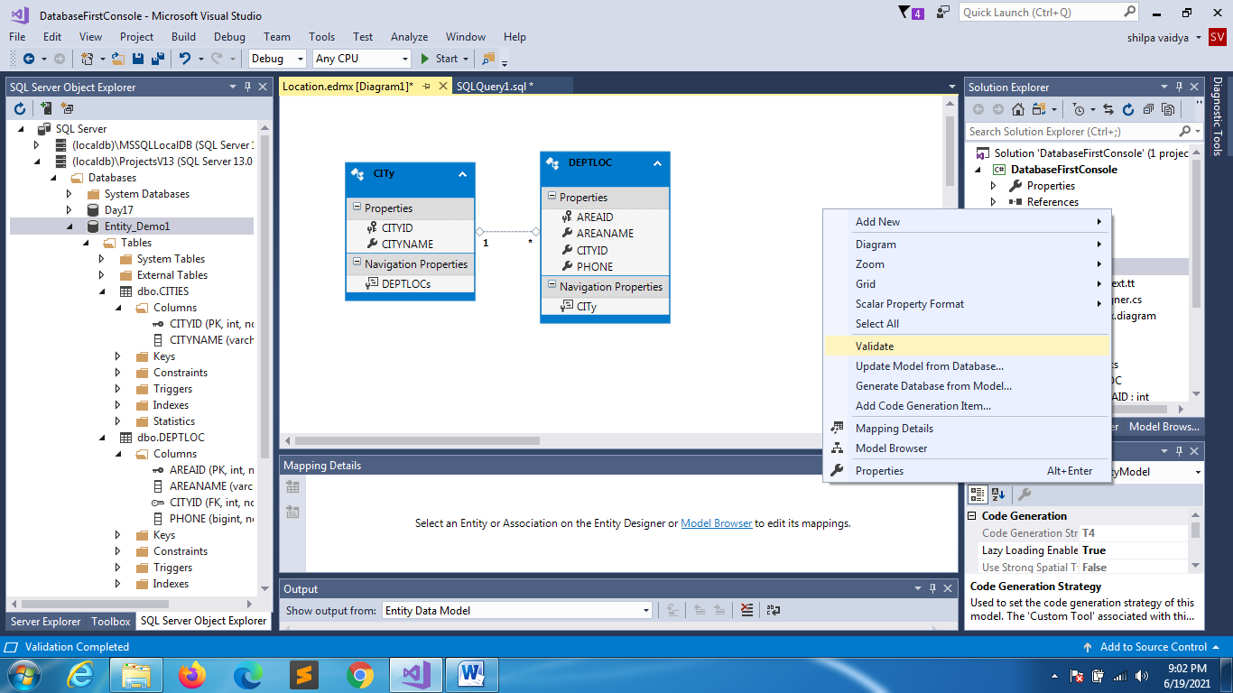

**FOR SEARCH IMPORT:**

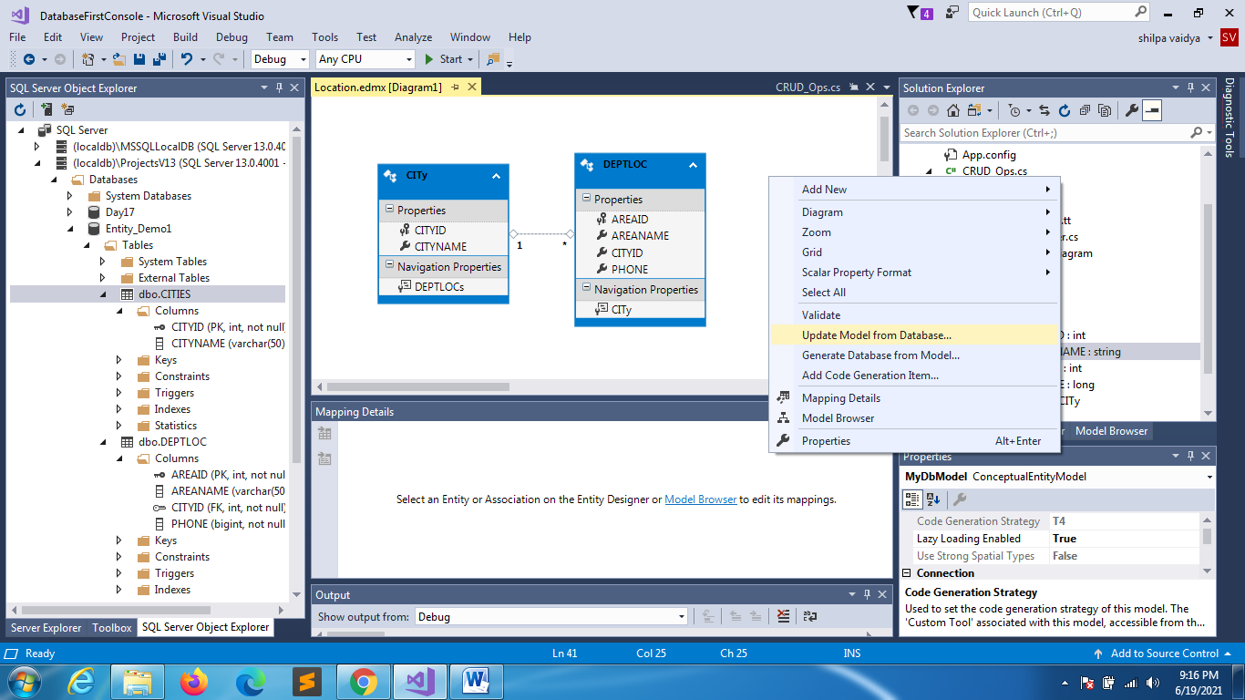

**Check import**

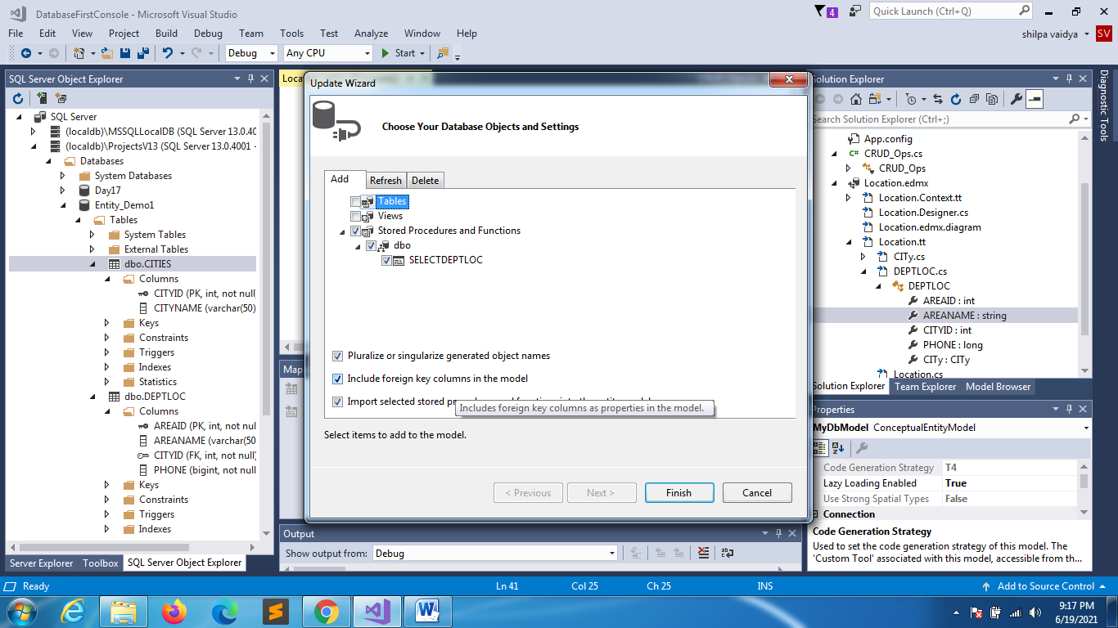

**CLICK ON MODEL BROWSER [right click on the modelbrowser]**

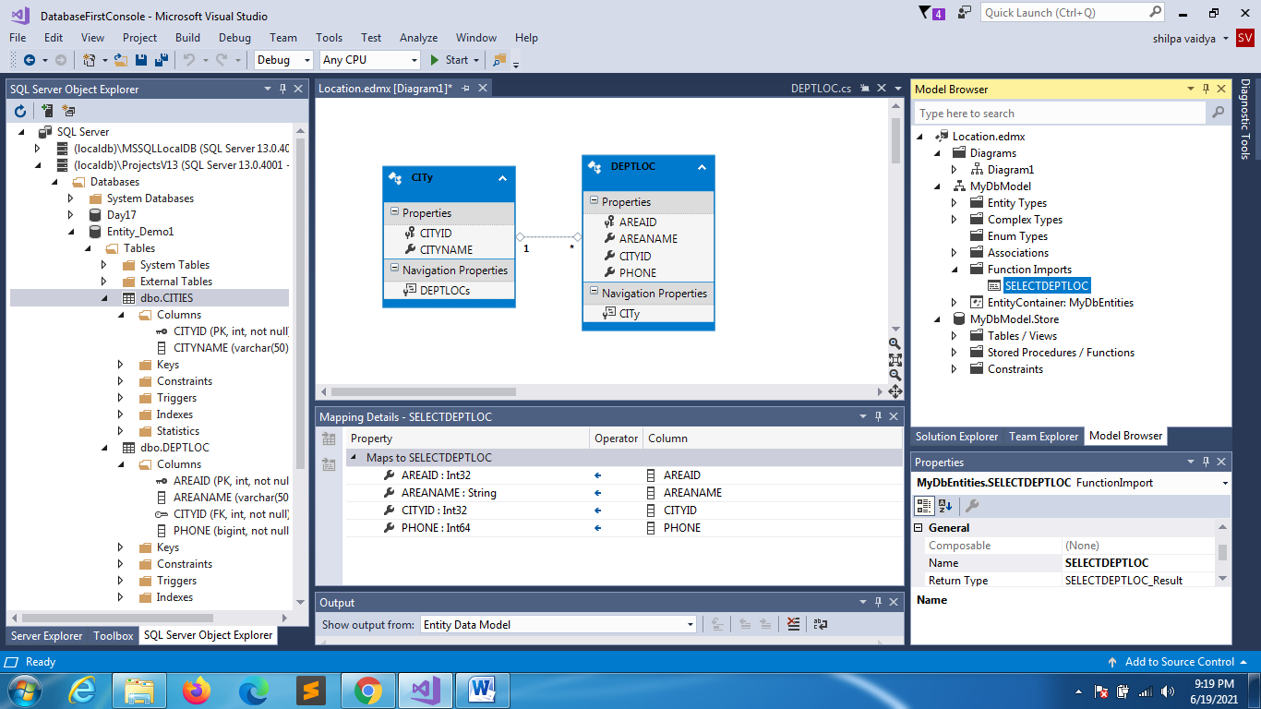

CHECK LOCATION.CONTEXT.CS

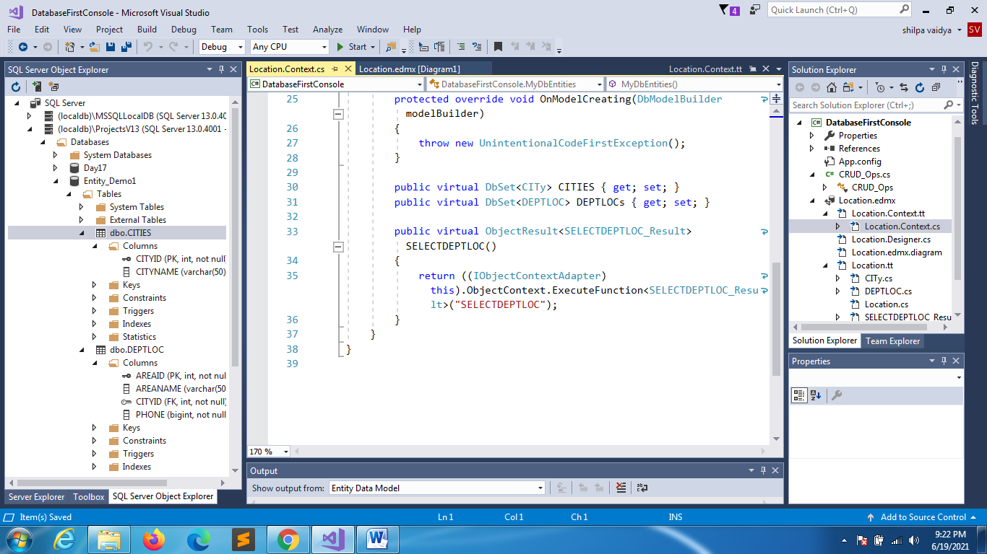

Automatically this function will generate after you save it

Go to model browser:

